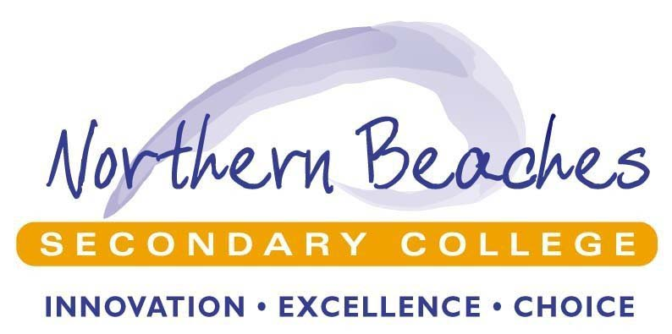

College Plan 2018 - 2020

Northern Beaches Secondary College

 | 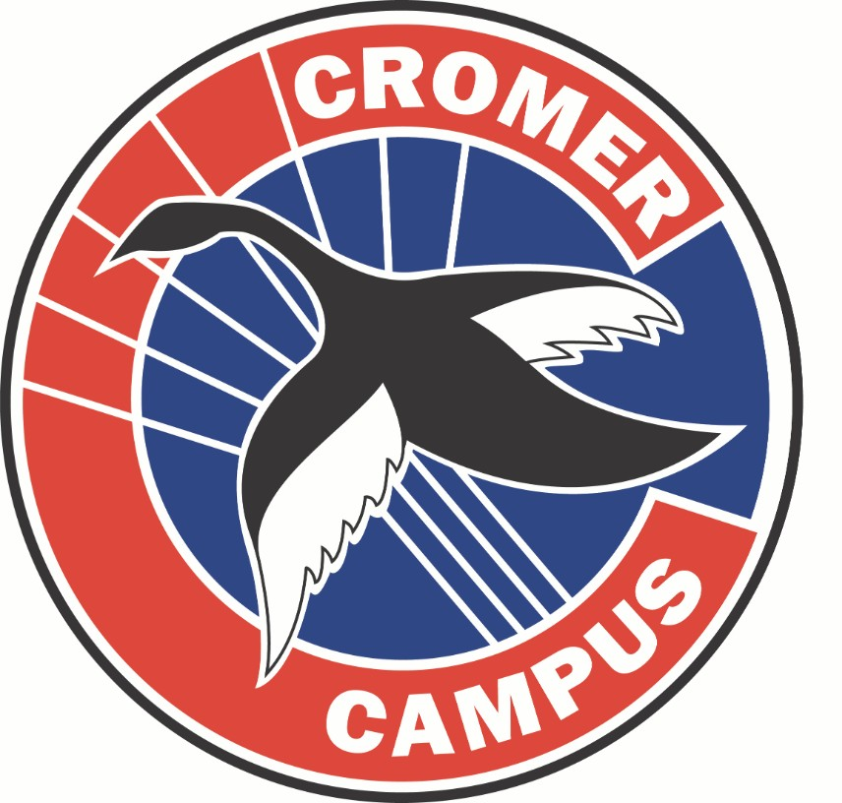 | 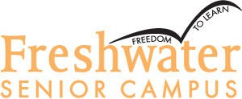 |  | 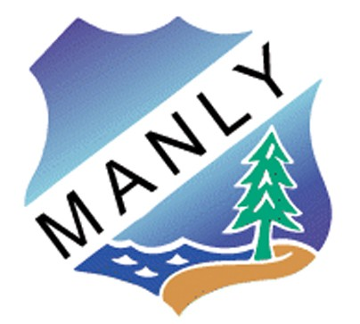
NBSC Balgowlah Boys Campus | NBSC Cromer Campus | NBSC Freshwater Senior Campus | NBSC Mackellar Girls Campus | NBSC Manly Campus
NSW, Department of Education

Northern Beaches Secondary College
College Plan 2018 - 2020

STRATEGIC DIRECTION:

A COLLABORATIVE COMMUNITY

to enhance teaching and learning opportunities and student success.

Northern Beaches Secondary College is considered one school across five campuses, where collaboration is crucial for the sound functioning and development of the College. By developing a collaborative community across the NBSC campuses, teaching and learning opportunities and student success will be enhanced for all students at all campuses.

With reference to the Public Schools NSW - School Excellence Framework, in the area of Teaching, Collaborative Practice is identified as a key element of a school which is excelling. This is also linked in the area of Learning where collaborative practices is identified as a characteristic of an excelling school. Additionally in the area of Leading from the School Excellence Framework, collaboration and partnership development are also noted as highly significant for school excellence.

It is therefore most appropriate that NBSC have a single common strategic direction for all campuses collectively to develop significant opportunities to create a collaborative community.

COLLEGE VISION STATEMENT COLLEGE CONTEXT COLLEGE PLANNING PROCESS

Northern Beaches Secondary College is an innovative and flexible educational setting that provides choice and diversity in learning excellence.

As the largest school in NSW, with over 4500 students and 350 teaching staff over the five campuses, collaboration, cooperation and resource sharing are significant approaches to ensure school effectiveness.

NBSC has developed significant ongoing partnerships with local primary schools through the Northern Beaches Learning Alliance. Other partnership links are either established or being developed with tertiary education providers and local businesses.

A Positive Education Approach is the preferred framework to enhance student, staff and school learning and wellbeing across all campuses.

NBSC Balgowlah Boys Campus – Yr 7-12 boys NBSC Cromer Campus – Yr 7-12
NBSC Mackellar Girls Campus – Yr 7-12 girls

NBSC Manly Campus – Yr 7-12 academically selective NBSC Freshwater Senior Campus – Yr 11-12
Catering for students from a diverse local community, we are also increasingly attracting students from other areas to access particular specialist campuses.

Community educational aspirations are continually rising.

College Management Team (CMT) conducted general discussion about the identity and purpose of NBSC and three strategic directions.

Synthesis of ideas then created general consensus on these. Parent Advisory Group confirmed these general directions.
Individual campuses began the process to complete each campus plan including the strategic directions and improvement measures.

Drafting of the strategic directions continued with a working party from the CMT and CAC Head Teachers. A reduction to a single strategic direction with multiple projects was agreed.

Individual campus plans were finalised.

A summary of campus plans was used to synthesise common strategic directions and then correlated with earlier drafts of the NBSC plan.

A final draft was tabled to the CMT for revision and forwarded for confirmation to the Director Public Schools.

PURPOSE PEOPLE PROCESSES PRODUCTS AND PRACTICES

Why do we need this particular strategic direction and why is it important?
By enhancing a collaborative community across the NBSC campuses, teaching and learning opportunities and student success will be enhanced for all students at all campuses.

The collective responsibility of NBSC will be to provide quality educational experiences which are characterised by innovation, choice and excellence for all Northern Beaches Secondary College students at all campuses.

Deeper collaboration will serve to broaden current educational and future life opportunities, enhance the quality and breadth of teaching and learning and increase the individual and collective capabilities of student and staff.

IMPROVEMENT MEASURE/S

Improved student learning outcomes across the college as measured; increase in top two bands for all aspects of literacy and numeracy in NAPLAN testing.

Increased uptake and demonstration of Futures Learning Skills both across NBSC and within each campus. A consistent measure to be agreed and applied across all campuses.

.

How do we develop capabilities of our people to bring about transformation?

Students will develop or extend capabilities to:
.
- Develop skills for Futures Learning via exposure to specific teaching practices and
strategies.
- Show literacy and numeracy growth through the acquisition of specific and appropriate skills for each student context.

Staff will develop or extend capabilities through:

- Professional learning processes so that they acquire skills to enhance Futures learning skills, and the improvement of student literacy and numeracy involving differentiation.
- Training to assist the acquisition of peer coaching skills and techniques and to understand and manage their own wellbeing through whole school approaches.
- Professional development planning and implementation (at each campus) in relation to campus strategic directions and other priorities including: ALARM, Australian Curriculum and student transition.
- Networking opportunities and links within NBSC, with NBLA schools, tertiary education, business and the community.

Parents will develop or extend capabilities to:

- Understand how to assist student skills and wellbeing achievement through their participation in parent evenings.

Leaders will develop or extend capabilities to:

- Develop their personal capacity to assist the development and implementation of student

How do we do it and how will we know?

- Collective approaches will be taken to establish the interest and needs of students, to professional learning, to provide for beginning teachers, for NESA accreditation and the delivery of accredited courses within NBSC.

- Opportunities will be provided for staff to collaborate on curriculum and assessment planning and related structures and processes, on developing approaches to the Australian Curriculum, teaching ALARM in Stage 5 and student transition approaches in Stages 3 and 5.

- Peer Coaching using a Solution Focused approach in teacher development will be established as a NBSC approach and will involve training and agreed protocols.

- A whole college approach to train and develop staff understanding and appropriate strategies in Futures Learning Skills and differentiated literacy and numeracy outcomes for students.

- Sharing of methodologies and strategies will be assisted, both internally and externally of the NBSC. Staff will be encouraged to participate in NBLA and other external networks through effective communication.

What is achieved and how do we know?

Products:

Increased uptake and demonstration of Futures Learning Skills both across NBSC and within each campus. A consistent measure to be agreed and applied across all campuses.

Demonstrated increased literacy and numeracy skills both across NBSC and within each campus. This will be indicated by Year 9 NAPLAN data.

Increased number and type of collaborative arrangements occurring across and within NBSC as indicated by staff survey data.

What are our newly embedded practices and how are they integrated and in sync with our purpose?

Practices:

Collegiate structures are evident for curriculum, assessment planning, professional learning, and student transition.

Professional learning outcomes indicate changed classroom and whole school practice in Futures Learning Skills acquisition, literacy and numeracy, Australian Curriculum and ALARM delivery across all NBSC campuses.

resilience and wellbeing, Futures Learning Skills and professional learning initiatives.

Community partners:

  - Will be developed to enhance the quality of educational opportunities for NBSC students and to extend the available resources to teachers and students.

Leaders:

- Engage in professional learning to assist the development of strategic direction. Leaders model collaboration and assist staff to be involved in faculty and college networks, NBLA networks, business and community forums, including the allocation of resources where appropriate.
- A collective approach is demonstrated with NBLA schools, parents, tertiary education links and at community events.

Parents

- Complementary events and education opportunities for parents will be provided on resilience and wellbeing, Futures Learning Skills, transition, literacy and numeracy to encourage synergy of parents with NBSC initiatives.

Evaluation plan:

The College Management Team meetings will include evaluation activities and additionally as necessary feedback and/or data will be sort from other stakeholders. Processes will be developed to coordinate with various campus processes.

Practices: (continued)

Professional learning structures and processes are coordinated across NBSC and are communicated to stakeholders.

School leaders are identified as having collaborative approaches across NBSC and NBLA.

Parents and the Northern Beaches community have common experiences and understandings of educational practices and priorities

Effective links are evident between NBSC and tertiary education providers.

